**Nama : Wiwin Nur Kholifah  
NIM : 18090030  
Kelas : 5C**

* Materi

1. Source Code

viewlatihan2.php 🡪 application/views

Model1.php 🡪 application/models

latihan1.php 🡪 application/controllers

latihan2.php 🡪 application/controllers

1. URL

<http://localhost/web_wiwin/latihan1>

[http://localhost/web_wiwin/latihan1/penjumlahan/5/10](http://localhost/web_wiwin/latihan1/penjumlahan/5/10%20)

<http://localhost/web_wiwin/latihan2/penjumlahan/5/10>

1. Capture Hasil

* Latihan1

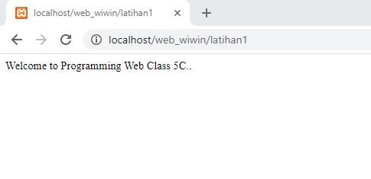

* Latihan1 penjumlahan

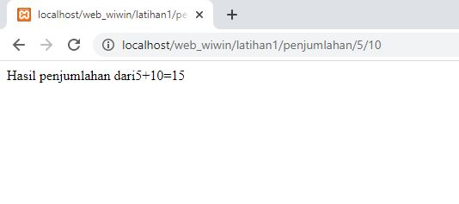

* Latihan2 penjumlahan

